**WEBSITE FOR COMPUTER SCIENCE AND ENGINEERING DEPARTMENT WITH ATTENDANCE MANAGEMENT**

**SMRUTI RANJAN BEHERA**

**1902040013**



Computer Science and Engineering

Veer Surendra Sai University of Technology, Burla

2022-2023

**WEBSITE FOR COMPUTER SCIENCE AND ENGINEERING DEPARTMENT WITH ATTENDANCE MANAGEMENT**

A minor project submitted in partial fulfilment of the requirements for the

Degree of

BACHELOR OF TECHNOLOGY

IN

COMPUTER SCIENCE AND ENGINEERING

By

SMRUTI RANJAN BEHERA

1902040013

Under the Guidance of

**Dr.Rakesh Mohanty**

**Associate Professor**



**DEPARTMENT OF COMPUTER SCIENCE AND ENGINEERING**

VEER SURENDRA SAI UNIVERSITY OF TECHNOLOGY

BURLA,ODISHA

**VEER SURENDRA SAI UNIVERSITY OF TECHNOLOGY**

**BURLA, ODISHA**



**Declaration**

We declare that this written submission represents our ideas in our own words and where other ideas or words have been included. We have adequately cited and referenced the original sources. We also declare that we adhered to all principles of academic and integrity and have not misrepresented or fabricated or falsified any idea/data/fact/source in our submission. We understand that any violation of the above will cause disciplinary action by the university and can also evoke penal action from the sources which have thus not been properly cited or from whom proper permission has not been taken when needed.

DATE SMRUTI RANJAN BEHERA

REGD NO - 1902040013

**VEER SURENDRA SAI UNIVERSITY OF TECHNOLOGY**

**BURLA, ODISHA**



**Certificate**

This is to certify that the minor project report on “**WEBSITE FOR COMPUTER SCIENCE AND ENGINEERING DEPARTMENT WITH ATTENDANCE MANAGEMENT** ” submitted by **SMRUTI RANJAN BEHERA** bearing Registration No. 1902040013 of 7th Semester, Bachelor of Technology is approved for the degree of **Bachelor of Technology in Computer Science and Engineering**, is a record of an original research carried out by them under my supervision and guidance.

Dr. Suvasini Panigrahy Dr.Rakesh Mohanty

Head of the Department Supervisor

**ABSTRACT**

In this report, i propose a project on “WEBSITE FOR COMPUTER SCIENCE AND ENGINEERING DEPARTMENT WITH ATTENDANCE MANAGEMENT.”

I have been presenting a website where I have developed a website regarding the details of our Computer Science And Engineering branch and there will be an attendance management system will be there which will help the faculties to take the attendance also there will be details of our faculties which will help the students to know our faculties well.

**TABLE OF CONTENTS**

1. Introduction…………………………………………………………….7
2. Literature Survey………………………………………………………7

3. Software Requirement Specification………………………………...8

3.1. Introduction……………………………………………………….8

3.2. Purpose…………………………………………………………...8

3.3. Project Scope…………………………………………………….8

3.4. User And It’s Characteristics……………………………………8

3.5. Design And Implementation Constraints………………………9

3.6. External Interface Requirements……………………………….9

3.7. Functional Requirements………………………………............10

4. Data Flow Diagram…………………………………………………….11

5. E - R Diagram…………………………………………………………..13

6. Activity Diagram………………………………………………………..15

7. Various Webpages Of Our Website………………………………….16

7.1. Homepage………………………………………………………..16

7.2. Login Panel……………………………………………………….18

7.3. Administrator Dashboad………………………………….……..18

7.4. Teacher Dashboard …………………………………………….19

7.5. Create Class……………………………………………………..20

7.6. Create Teacher…………………………………………………..20

7.7. Manage Student…………………………………………………21

7.8. View Student Attendance……………………………………….21

8. Conclusion………...…..……………………………………………….22

# **1. INTRODUCTION**

Web programming also known as the language of internet helps to view the world of internet. Web-development helps to make the work easier for the websites. I have been presenting a website where I have developed a website regarding the details of our Computer Science And Engineering branch and there will be an attendance management system will be there which will help the faculties to take the attendance also there will be details of our faculties which will help the students to know our faculties well.Anyone in the branch can get a view of our department when they visit our website and outsiders also can have the look of our department but the access of admin and teacher page can be accessed by only the officials.

# **2. LITERATURE SURVEY**

Every time a website is seen even when I look at out college website I thought of having a website of our branch of it’s own.Through the website I want to showcase our branch and it’s specifications.The details of our branch faculties will be also there for showcase.The main motive of the website is to have a attendance management system which will help our faculties to execute the attendance better.As the attendance is 75% compulsory here that’s why attendance management is a must thing here.Although there is a physical way to take the attendance but online it will be more accurate and easier to handle.

# **3. SOFTWARE REQUIREMENT SPECIFICATION -**

**INTRODUCTION**: - This represents the SRS of the following website we are going to design and this will help us track our progress and gives a brief description of our application.

**PURPOSE**: - The main purpose of our website is to provide the proper knowledge of our branch to the public and build a attendance management system also which will help our faculties.

**PROJECT SCOPE**: - We may discover a statement with details about the project under the Product Scope Description section of the project. The qualities of the product are typically the subject of this information. Here we have to manage the admin as well as the teahcers so that there will be no problem and our website will work smoothly. We will manage the preference of the users and provide them various functionalities and also at the same time. This website will help to the teachers as well as the students.

**USER AND IT’S CHARACTERISTICS: -** A user class is a group of properties (characteristics) and methods (behaviors) established by the developer that you can use to refer to several pieces of data as a single entity. The website's design and its ability to be interactive for users are both heavily influenced by the system's users. Users, teachers, and administrators are also a part of it .

The actors can be classified under the user classes below:

• Admin

• Teachers

• Students

| Admin | * Registration * Login * Manage teachers and class * Manage Stats |
| --- | --- |
| Teachers | * Registration * Login * Manage Students * Manage attendance |
| Students | * View Website * See Features |

**DESIGN AND IMPLEMENTATION CONSTRATINS:-**

• Regulatory Policies: No regulatory policies were necessary for this app's design.

• Hardware Restriction: There are no hardware restrictions.

• Interfaces to other applications: Since we only pay the agent when the task is finished, there is no external interface for online bill payment given.

• Parallel operations: There aren't any.

• Auditing Activities: There won't be any auditing activities.

• Control functions are prohibited. There shall be none.

• Username and password security requirements: Users must keep their username and password confidential. To protect users' privacy, the user must log in before making a travel reservation.

• Reliability Requirements: All flaws in the system must be less than 1% of all lines of code, with the exception of connection reliability, which is not met.

• Criticality of the Application: The server applications shall be available 365 days.

**EXTERNAL INTERFACE REQUIREMENTS:-**

Travel apps are web-based systems for online data entry and display. The system's user-friendly Graphical User Interfaces are used by all users to engage with it (GUI). The design document must include the forms of the system's many GUIs, including the screens, web pages, and reports.

**HARDWARE INTERFACES**: The system doesn't need any hardware interfaces.

**COMMUNICATION INTERFACES**: Internet Explorer 7.0 or another web browser will be used by users to access the programme. Both the SMTP protocol and the common HTTP protocol will be used for the communication.

**FUNCTIONAL REQUIREMENTS:-**

**ACTOR-ADMIN**

**R1-REGISTRATION**

Registration can be done by giving details like id , phone number , email and legit passowrd.

**R2-LOGIN**

Admin can login using registered email id and password.

**R3-MANAGE TEACHERS AND CLASS**

Admin can manage teachers and classes by adding or deleting classes or teachers.

**R4-MANAGE STATITICS**

Admin can manage teachers and classes by adding or deleting classes or teachers.

**ACTOR-TEACHER:-**

**R1-REGISTRATION**

Registration can be done by giving details like id , phone number , email and legit passowrd.

**R2-LOGIN**

Admin can login using registered email id and password.

**R3-MANAGE STUDENT**

Can add or delete students from classes.

**R4-MANAGE ATTENDANCE**

Can take attendance and manage

# **4. DATA FLOW DIAGRAM (DFD)**

A data-flow diagram (DFD) shows how data "flows" through an information

system graphically. DFD’s can be utilised to visualise data processing

(structured design). The DFD is often referred to as a bubble chart or a data

flow graph.

On a DFD, an internal process transfers data items from an external data source

or internal data store to an external data sink or internal data store.

A DFD does not provide details on the timing of processes or whether they will

run sequentially or concurrently. As a result, it differs significantly from a

flowchart, which depicts the control flow via an algorithm and enables the As a

result, it differs significantly from a flowchart, which depicts the control flow

through an algorithm and enables the reader to determine which operations will

be carried out, in what order, and under what conditions, but not what types of

data will be input to and output from the system, where the data will come from

and go, or where the data will be stored.

**SYMBOLS OF DFD :-**

|  | dataflow | Arrows showing direction of flow |
| --- | --- | --- |
|  | process | circles |
| _____________  _____________ | file | Horizontal pair of lines |
|  | Data - source , sink | Rectangular box |

**DATA FLOW DIAGRAM LEVEL - 0**

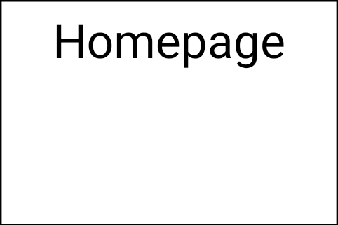



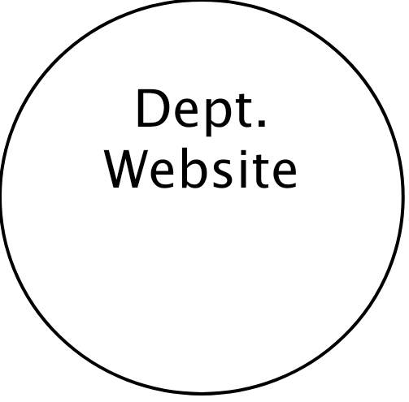

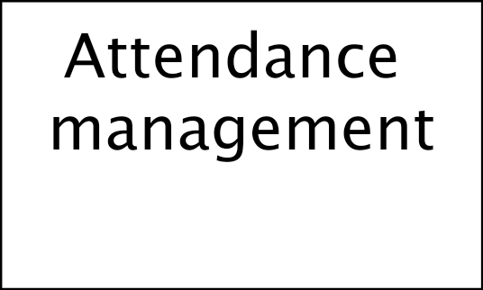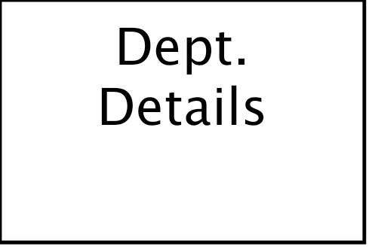

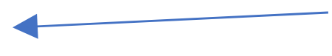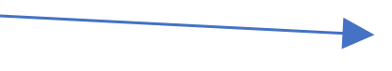



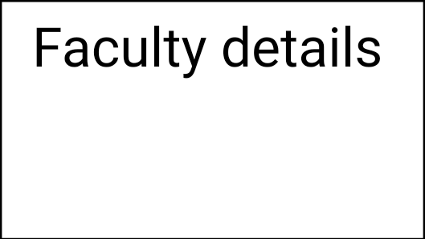

**DATA FLOW DIAGRAM LEVEL - 1**

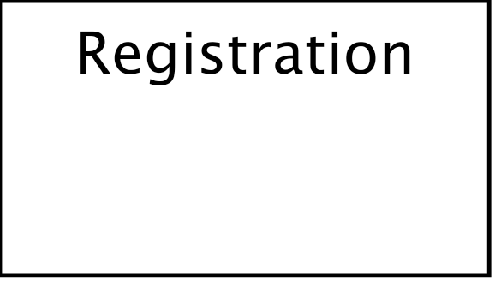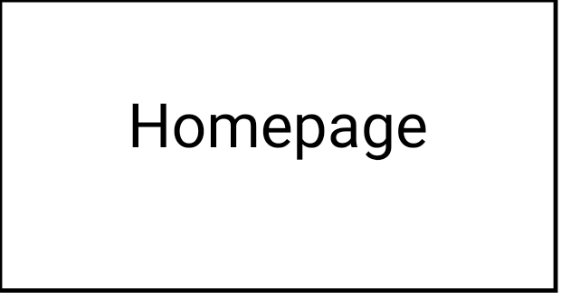

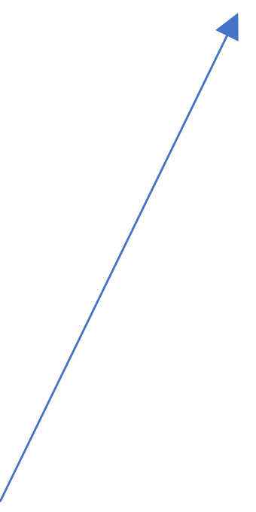

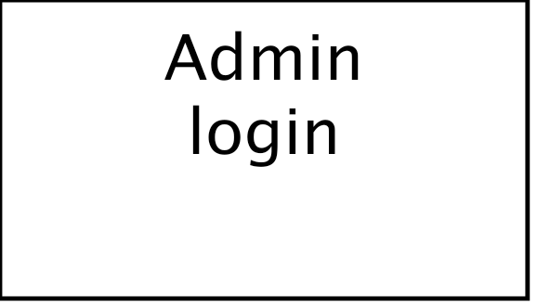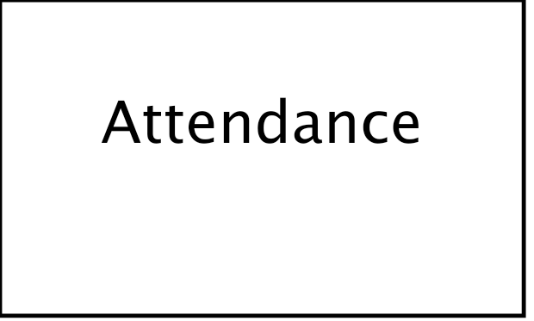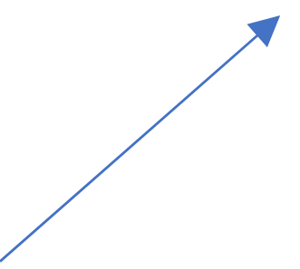

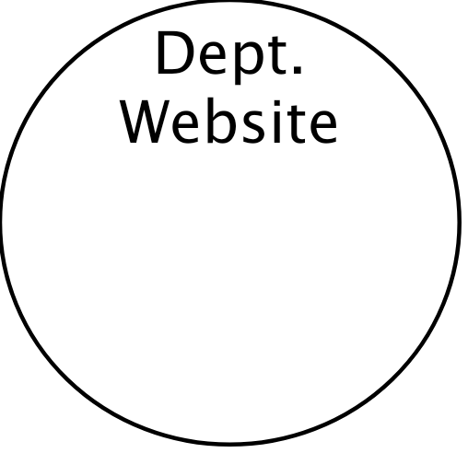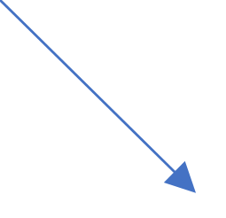

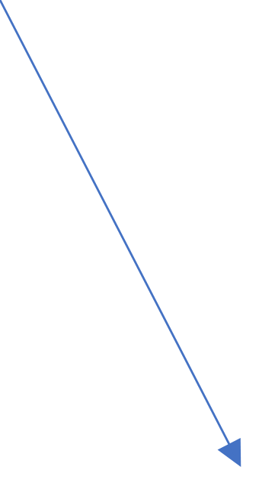

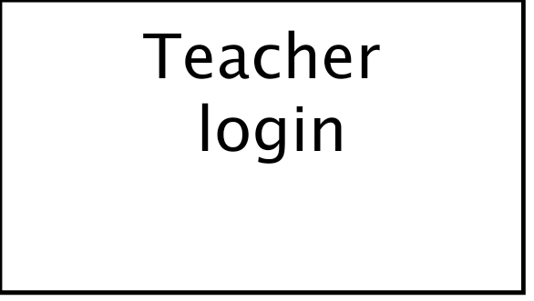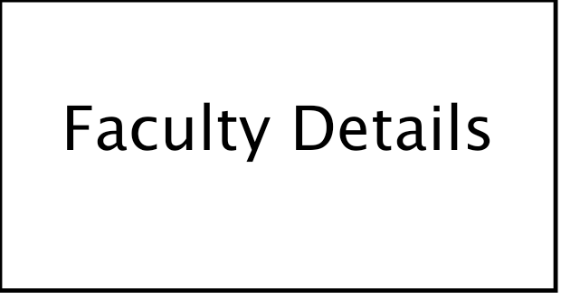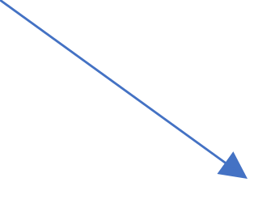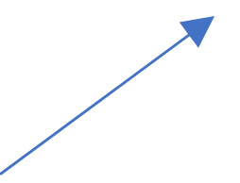

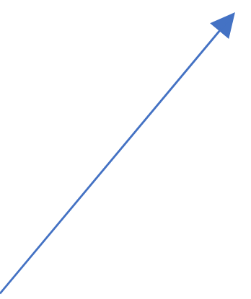

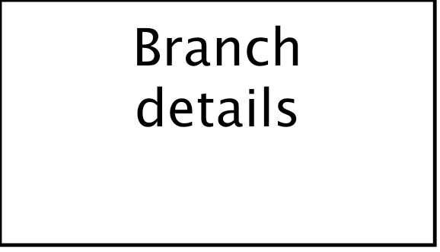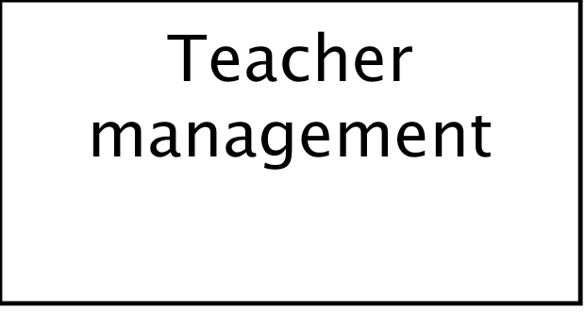

# **5. ENTITY RELATIONSHIP DIAGRAM (ERD)**

An Entity Relationship Diagram (ERD) is a visual representation of different data using conventions that describe how these data are related to each other. In the given ER diagram, the elements inside rectangles are called entities while the items inside diamonds denote the relationships between entities.

• Entity: An entity can be a person, place, event, or object that is relevant to a given system. Entities are represented in ER diagrams by a rectangle and named using singular nouns.

• Relationship: A relationship describes how entities interact. Relationships are represented by diamond shapes and are labelled using verbs.

• Cardinality: Cardinality is the number of instances of an entity from a relation that can be associated with the relation.

One-to-one: When only one instance of an entity is associated with the relationship, it is marked as **1:1**. 

One-to-many: When more than one instance of an entity is associated with a relationship, it is marked as **1: N**. 

Many-to-one: When more than one instance of an entity is associated with the relationship, it is marked as **N:1**.

**USER –** User plays of 2 roles.

User is a Admin.

User is a teacher.

**ADMIN-** Admin can add many teachers.

Admin can add many classes

**TEACHER-** Teacher can add many students

Teacher can take attendance.

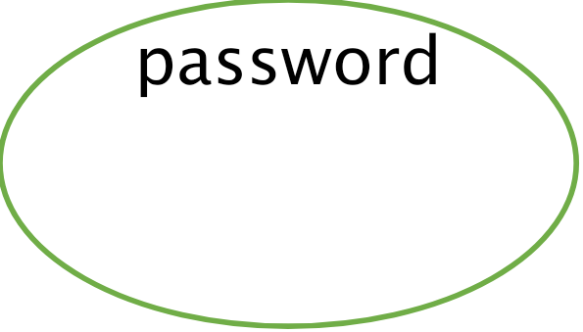

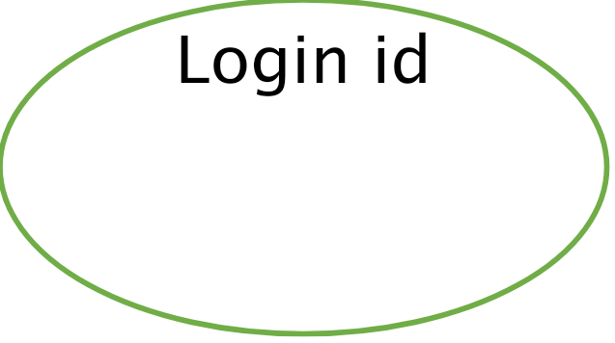

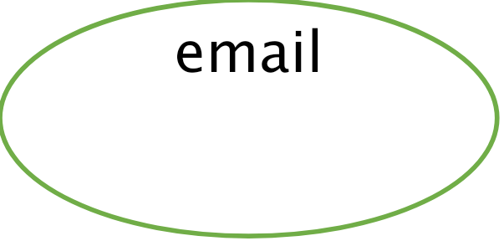



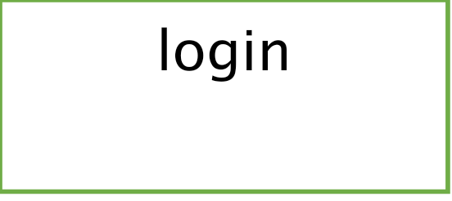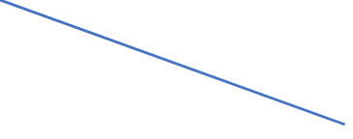

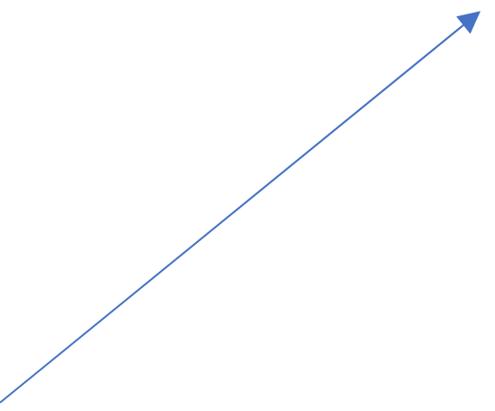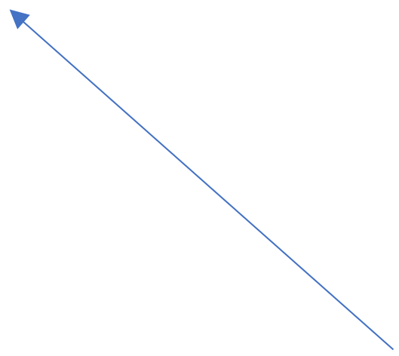

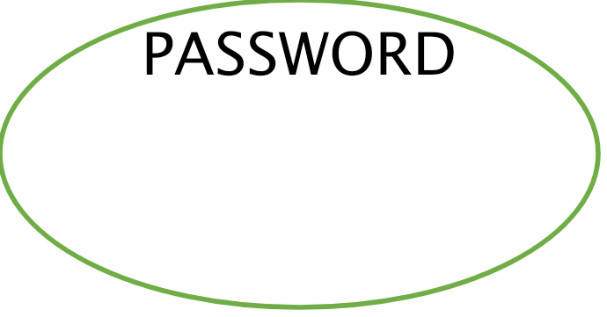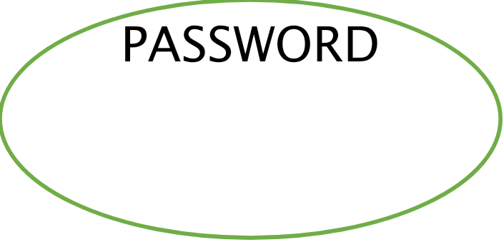

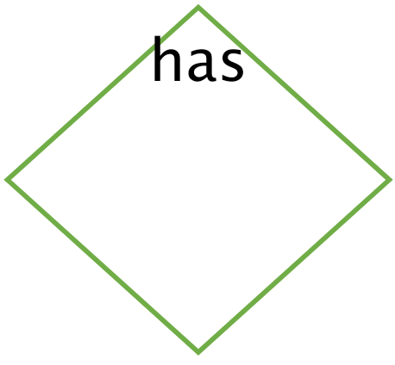



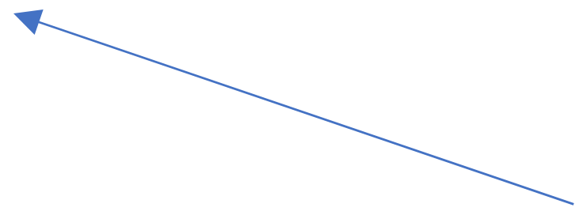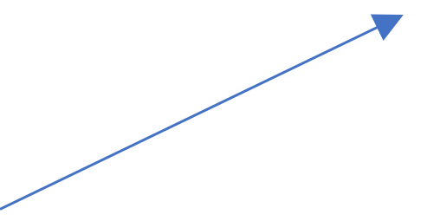



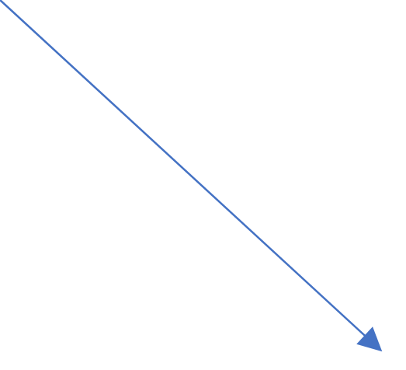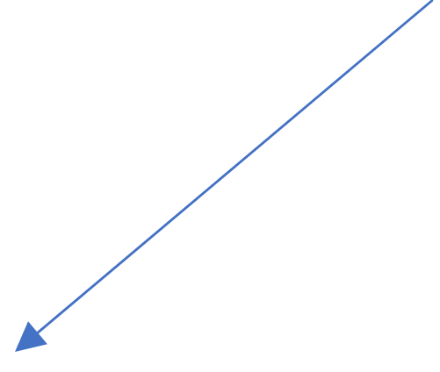

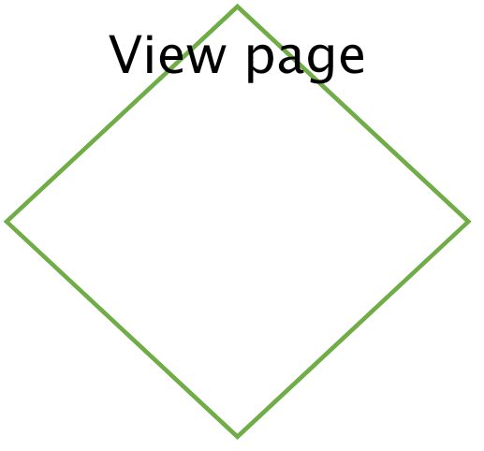

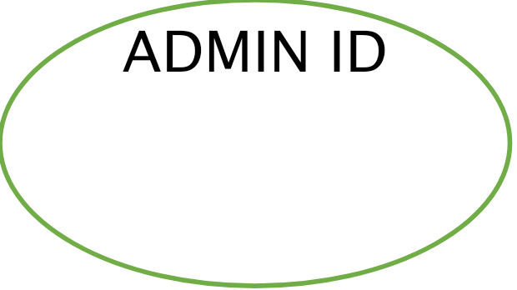



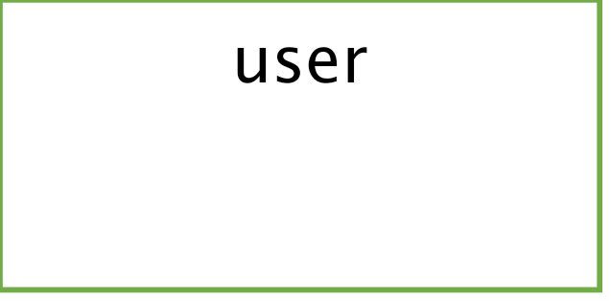

# **6. ACTIVITY DIAGRAM**

Activity diagram is another important behavioural diagram in diagram to describe dynamic aspects of the system. Activity diagram is essentially an advanced version of flow chart that modelling the flow from one activity to another activity.

In this activity diagram, we explained the whole process of our application where we start with registering and giving details of the user as well as the admin. Then by providing use_rid and user_pswd, we can login into the website.

In this way, we can collect some ideas about our field on how to improve our performance of the application.

**ADMIN/TEACHER-**

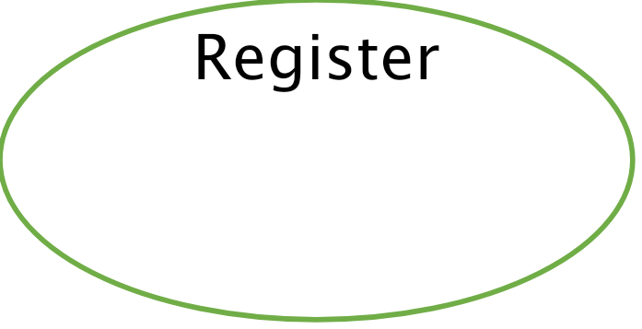



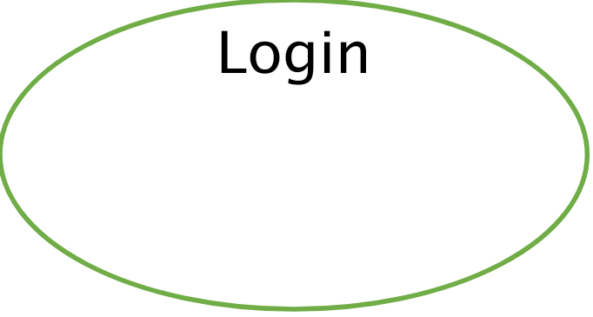

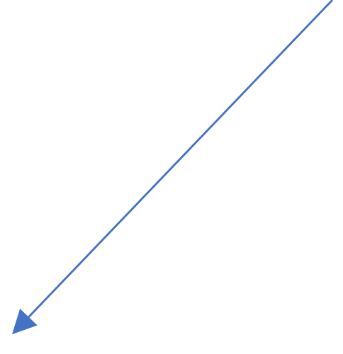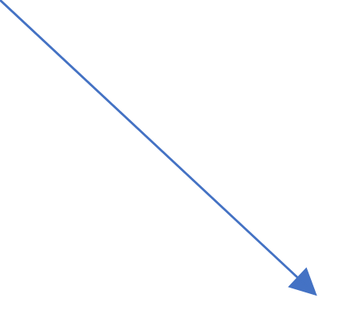

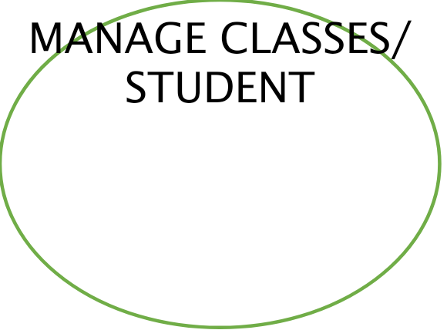

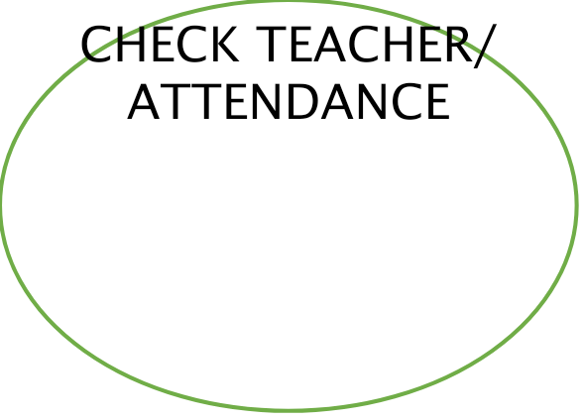

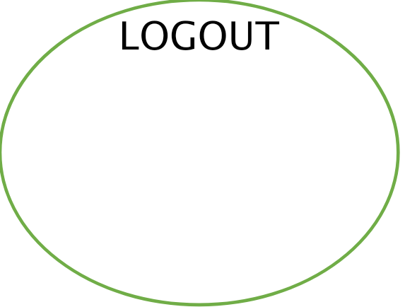

# **7. VARIOUS WEBPAGES OF OUR WEBSITE**

**HOMEPAGE-**



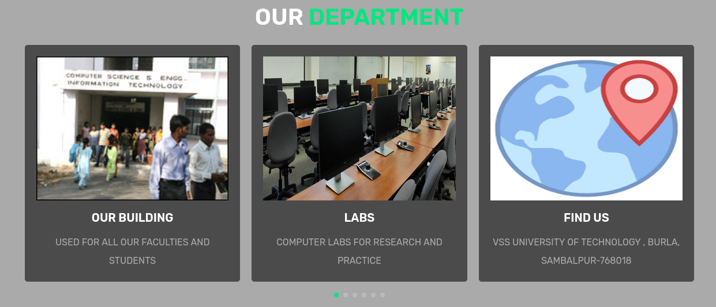

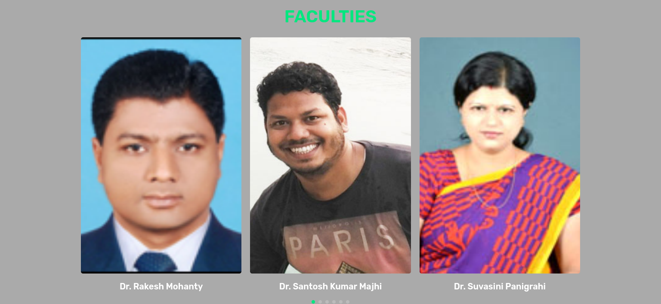

The homepage contains details about our computer science branch where is shows some of important topics regarding our branch like the facilities available,the details of some of our faculties as well as their social media handles.And at last the attendance option also there which will redirect to the attendance panel where the attendance management system is.

The options in home page is-

* **HOME**
* **SPECIALTIES**
* **COURSES**
* **FACULTIES**
* **ALUMNI EXPERIENCE**
* **ATTENDANCE**

These are the options which will help users to find about our branch.

**LOGIN PANEL-**

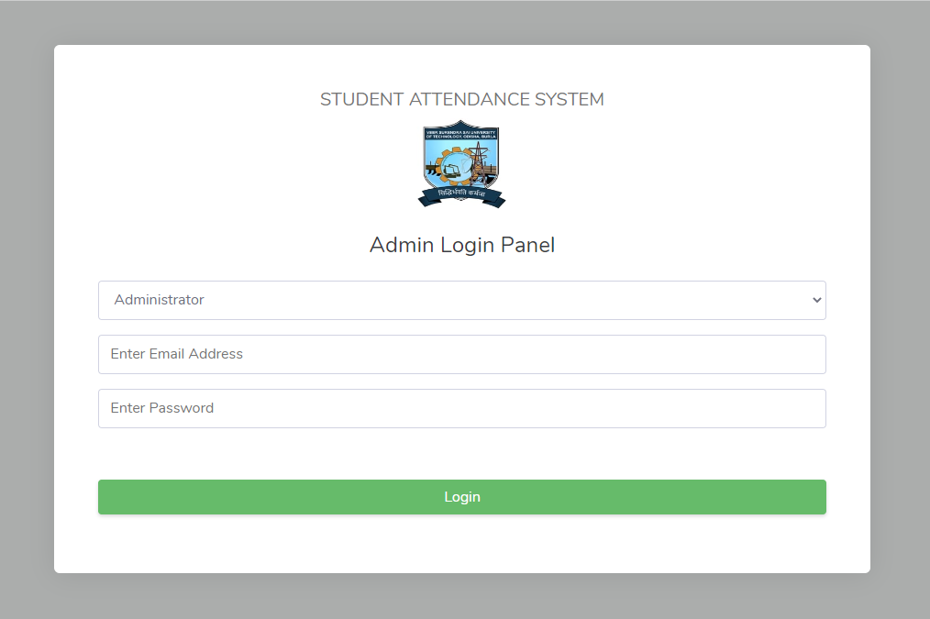

This is the login page of our website containing the options of administrator or teacher. We will have to choose one between them and when we will put the email id and password the panel will open. The administrator will have the admin dashboard while the teacher will have the teacher dashboard.

**ADMINISTRATOR DASHBOARD-**

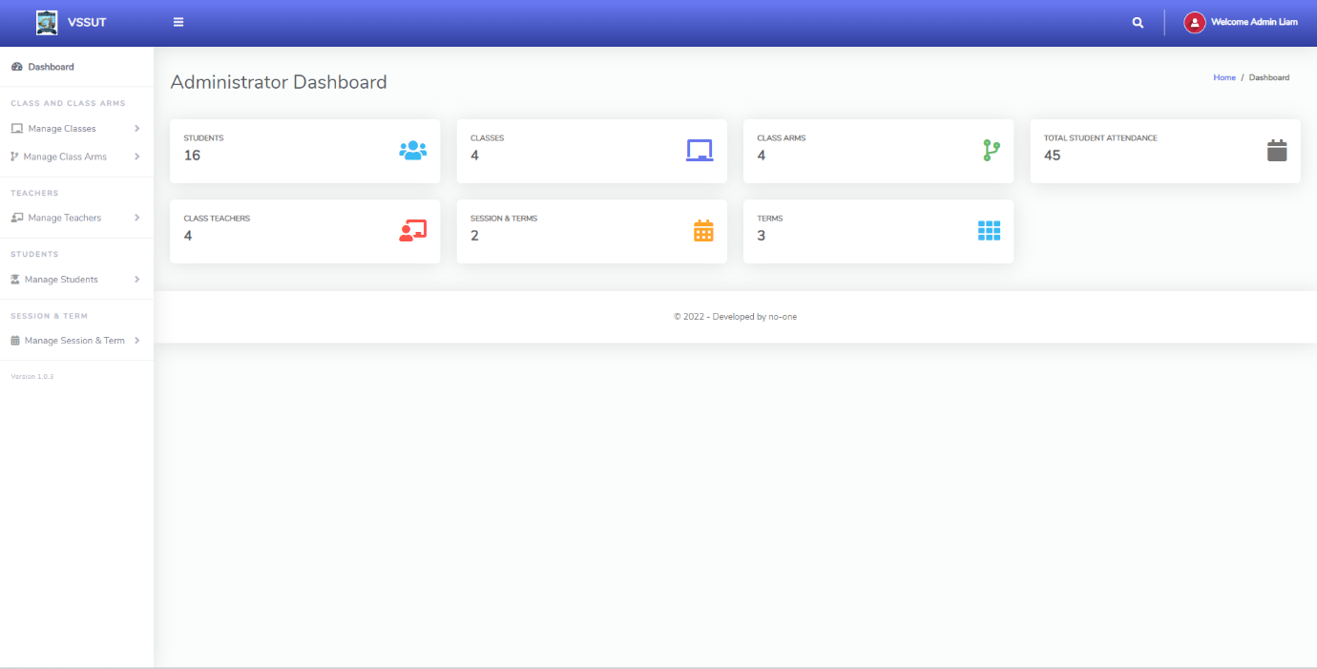

The administrator dashboard contains options which will help the admin to regulate the teachers and the classes.Using this the admin can add students as well as classes.

The admin have the count of all students and can regulate the student count also.

**TEACHER DASHBOARD-**

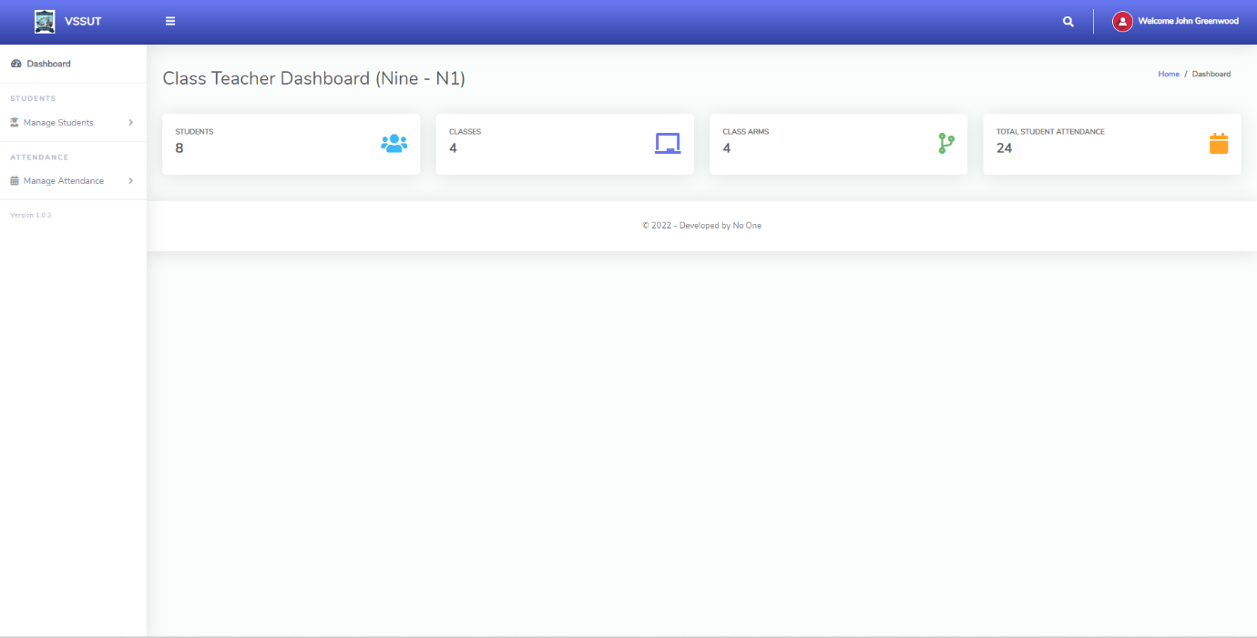

The teacher dashboard contains options which will help the teacher to regulate the attendance and the classes.Using this the teacher can manage students and can manage attendance also

The teacher can also have the count of total number of students.

**CREATE CLASS-**

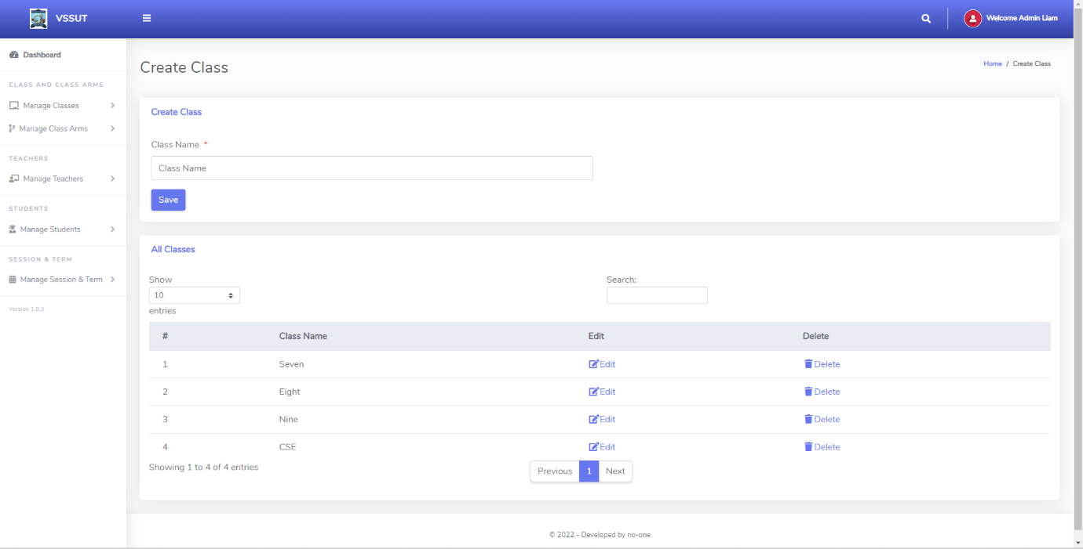

The create class page is used to create a class which will contain students and it will help the teacher to manage the attendance although it is created by the admin.

**CREATE TEAHCER-**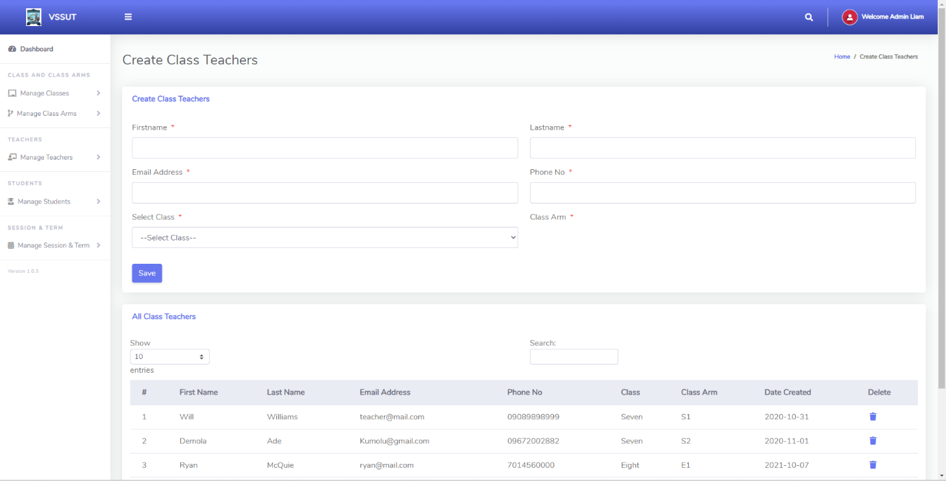

The create teacher page is used to create a teacher profile which will have the details of teachers also.The teacher are also enrolled with a class which he/she will take.

**MANAGE STUDENT-**

# 

Students can be managed here, Example - add delete or anything.

**VIEW STUDENT ATTENDANCE-**

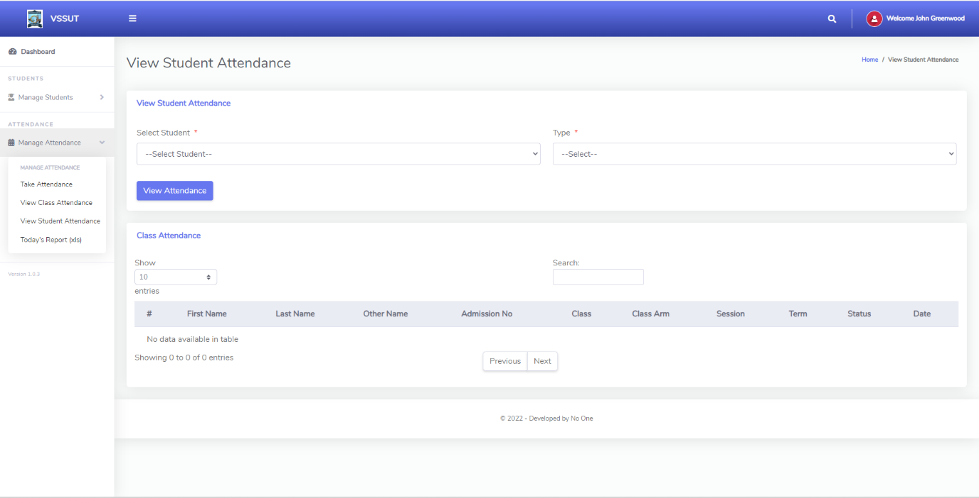

The attendance can be seen here.

# **8. CONCLUSION**

I have been presenting a website where I have developed a website regarding the details of our Computer Science And Engineering branch and there will be an attendance management system will be there which will help the faculties to take the attendance also there will be details of our faculties which will help the students to know our faculties well.Anyone in the branch can get a view of our department when they visit our website and outsiders also can have the look of our department but the access of admin and teacher page can be accessed by only the officials.

Every time a website is seen even when I look at out college website I thought of having a website of our branch of it’s own.Through the website I want to showcase our branch and it’s specifications.The details of our branch faculties will be also there for showcase.The main motive of the website is to have a attendance management system which will help our faculties to execute the attendance better.As the attendance is 75% compulsory here that’s why attendance management is a must thing here.Although there is a physical way to take the attendance but online it will be more accurate and easier to handle.

I hope this website will help our branch and as well as improve my web-development skills.